Math 1031 Test 2 Part B Full Name & Student # __________________
Scans/Pics of All pages must Be Uploaded to BB – 60 Marks

17. Find for the following data set (Q# a-f; 2 marks each):
10.0, 10.8, 10.9, 11.2, 11.4, 11.4, 11.6, 11.6, 11.7, 11.8, 12.0, 12.2, 12.4, 12.9, 13.3, 13.4, 13.5, 14.6, 15.7, 17.4, 18.3, 19.0, 19.4, 19.4, 19.4, 19.5, 19.7, 19.8, 19.9,
a) The mean = 14.6
b) The median = 13.3
c) The mode = 19.4
d) The range & mid-range = 9.9 / 14.95
e) Which do you think is the better Measure of Central Tendency? Why?
The better measure of central Tendency is mean because it reduces the errors associated with prediction of any single value within the date.
f) Comment on the skewness and the shape of the distribution. (Hint: you don’t have to graph in order to answer, there is another way….)
This data has a negatively skewed distribution in that there is a cluster of high values and a spread out tail on the left.

18. The average mark of 25 students in a class was 82. Another student took a make-up test and the class average dropped by 2 marks. What was the mark of that student who took the make-up test? (2 marks)
Solution
Total marks for 25 students = 25 x 82= 2050
Total marks after another student did a make-up= 26 x 80= 2080
The difference in marks = 2080-2050= 30
The student who took a make-up scored 30 marks

19. The following data represent the systolic blood pressure reading in mmHg for each of 10 randomly selected middle-aged males who were taking a blood pressure medication:
130, 144, 127, 169, 127, 121, 144, 149, 125, 148
- Calculate the mean, median, and mode for the data (3 marks).

Mean = ___138.4___, Median: _137_______, Mode: ___127 and 144_____

- Calculate the 10% trimmed mean for the data (2 marks).
Solution

Arranging the data in ascending order:
121, 125, 127,127,130,144,144, 148, 149, 169

For a 10% trimmed mean, we omit 121 and 169 from the list and find the average of the remaining values.
Thus: Ẋ₁₀= $\frac{125+127+127+130+144+144,+148+ 149}{8}$ = 136.75

10% trimmed mean= 136.75

20. The following table shows the frequency distribution of the number of hours/week spent on cell phones by 100 college students (2marks each x3 = 6 marks).

Hours per Week | Frequency (ƒ) | Midpoint | Weighted Class Midpoint | Cumulative Frequency
0 to under 10 | 9 | 5 | 45 | 9
10 to under 20 | 20 | 15 | 300 | 29
20 to under 30 | 36 | 25 | 900 | 65
30 to under 40 | 25 | 35 | 875 | 90
40 to under 50 | 10 | 45 | 450 | 100
Totals | 100 |  | 2570

a) The mean = 25.7
b) The median = 25.33
c) The modal class = 20 to under 30

21. A personal trainer recorded the average speed (in km/h) of his client running 5 laps of a 1-km track: {9.8, 11.1, 9.2, 10.3, and 9.7}. Determine the client’s average speed over the 5-km run. (2 marks)
Average speed = $\frac{9.8 +11.1+9.2+10.3+9.7}{5}$ = 10.02 km/h

22. The following table lists the scores a student received and the weights for each assignment. Calculate this student’s final grade. (2 marks)
Assignment | Mark (x) | Weight (w) | Weighted Mark (x•w)
Quizzes | 75 | 20% | 15%
In Class Group Work | 85 | 15% | 12.75%
Midterm Exam | 70 | 25% | 17.5%
Final Exam | 62 | 40% | 24.8%
Totals |  | 100% | 70.05%

Students final Grade= 70.05%

23. The rates of return on investment earned by a pharmaceutical company for four successive years were 15%, -10%, 20%, and 35%. What is the geometric mean rate of return on the investment by this company? (3 marks) (Hint: -10% from 100% = ?)
Solution
((1+0.15) x (1-0.1) x (1+0.2) x (1+0.35))^($\frac{1}{4}$)
= (1.15 x 0.9 x 1.2 x 1.35) ^ ($\frac{1}{4}$)
= 1.138
From the value, the growth rate is 0.138 or 13.8 %
Rate of Returns = 13.8%

24. A dental office is doing an inventory of the number of pairs of latex gloves used by hygienists over the past six months. The amounts were
272, 246, 216, 298, 301, 245.
- What is the average monthly usage (arithmetic mean) of pairs of latex gloves? (2 marks)

Mean= $\frac{272+246+216+298+301+245}{6}$ = 263

Average Monthly Usage =263
- If each pair of latex gloves costs $0.85, what is the estimated monthly cost for the latex gloves used per hygienist? (1 mark)

263 x $0.85= $223.55

Cost = _$223.55______
25. The mean price that five passengers paid for a domestic flight is $420 per ticket. The first three passengers paid $485, $530, and $333 from various sources. If the fourth and fifth passengers paid the same amount, what was the price of each of their tickets? (2 marks)
Solution
Let the amount paid the fourth and fifth passengers be x
Mean price= $\frac{\$485+\$530+\$333+\$x+\$x}{5}$ = $420
This implies that = $1348 +$2x= $420x5
= $2x= $2100-$1348=$752
X= $\frac{\$752}{2}$=$376
Price= $376
26. For the following data set: 65, 84, 85, 86, 88, 97, 117, find Q1, Q2, Q3 (6 marks)
Q1= 84
Q2= 86
Q3= 97
27. A medical accountant checks the electric bills for a medical clinic for a six-month period. The mean is $375.89 and the mode is $374.50. Using the empirical relationship, estimate the median and comment on the skewness of the distribution. (3 marks)
Solution
Empirical relationship:
Mean-Mode = 3 (Mean- Median)
Mean=$375.89
Mode = $374.50
That is:
$375.89- $374.50= 3($375.89 - Median)
$1.39= $1127.67 – 3 Median
Medain= $\frac{\$1127.67- \$1.39}{3}$ =$375.42
Skewness of the data: There is a normal distribution of data since the measures of central tendency are almost equal.

28.An study was done to determine the average length (cm) of the newly discovered snake with a mean length of 500 cm and a standard deviation of 100 cm. Use the empirical rule to answer the following:
a) Draw this normal distribution on the graph below and label the mean and all three (3) standard deviations; percentages and real numbers. (3 marks)
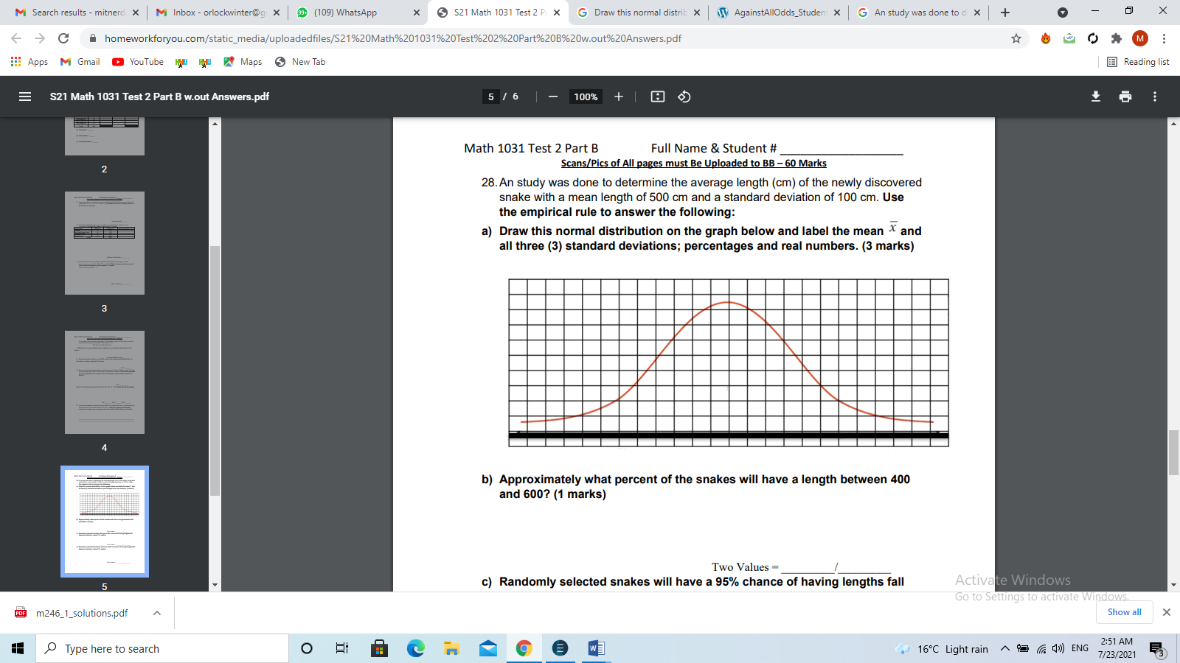
Mean
68%
1000
600
100
900
800
700
200
300
400
500
95%

99.7%

b) Approximately what percent of the snakes will have a length between 400 and 600? (1 marks)

Two values = 68 %

c) Randomly selected snakes will have a 95% chance of having lengths fall between what two values? (1 marks)
Two values= 300/700
d) Randomly selected students will have a 99.7% chance of having lengths fall between what two values? (1 marks)
Two values= 200/800

29. A patient records her daily blood pressure (in mmHg):
 | Systolic | Diastolic
Monday | 146 | 92
Tuesday | 132 | 84
Wednesday | 154 | 102
Thursday | 128 | 88
Friday | 166 | 110
Saturday | 140 | 96
Sunday | 152 | 86

- Determine the range for both types of blood pressure. (2 marks)
Range = Systolic= 166-128 = 38
Range Diastolic= 110-84=26
- Using the Range Rule of Thumb estimate the standard deviation for both types of blood pressure. (2 marks)

Systolic = $\frac{38}{4 }$= 9.5
Diastolic = $\frac{26}{4}$ = 6.5
- c. Calculate the standard deviation for both types of blood pressure using the exact data. (6 marks)

Systolic | 𝒙̅ | (𝒙 − 𝒙̅) | (𝒙 − 𝒙̅) 𝟐 | Diastolic | 𝒙̅ | (𝒙 − 𝒙̅) | (𝒙 − 𝒙̅) 𝟐
146 | 145.43 | 0.57 | 0.32 | 92 | 94 | -2 | 4
132 | 145.43 | -13.43 | 180.36 | 84 | 94 | -10 | 100
154 | 145.43 | 8.57 | 73.44 | 102 | 94 | 8 | 64
128 | 145.43 | -17.43 | 303.80 | 88 | 94 | -6 | 36
166 | 145.43 | 20.57 | 423.12 | 110 | 94 | 16 | 256
140 | 145.43 | -5.43 | 29.48 | 96 | 94 | 2 | 4
152 | 145.43 | 6.57 | 43.16 | 86 | 94 | -8 | 64
total |  | 0 | 1053.68 |  |  |  | 528

Systolic Standard Deviation=$\sqrt{\frac{\sum{(x - x̅) 2}}{N}}$ = $\sqrt{\frac{1053.68}{7}}$ =12.27
Diastolic Standard Deviation = $\sqrt{\frac{\sum{(x - x̅) 2}}{N}}$ = $\sqrt{\frac{528}{7}}$ = 8.68
- Compare the standard deviations of both sets of data and make an opinion concerning their spreads. (1 mark)
The standard deviation obtained through range rule of thumb is close to the actual standard deviation.

